**Project 1**

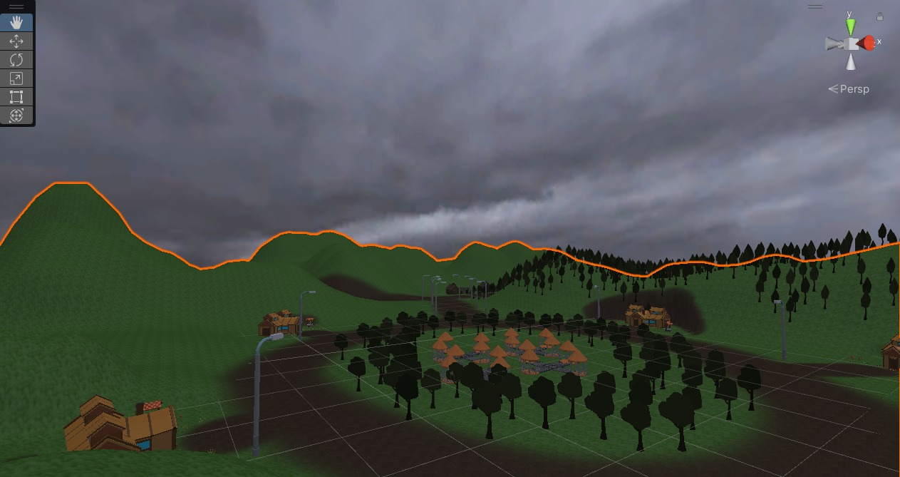

**Game Title**: “Mortals Vs. Zombies”

**Group Members**: Mohamad ElBaba – Mohamad Salman – Mona Al Yahfoufi (201807099) – Nahla Baalbaki (201901434)

**Group Contributions:**

* Download Assets from the Asset Store and Design the Map (Mona and Nahla together during meetings)
* Write the Technical Game Document and the Game Development Document (Mona and Nahla)
* Write Scripts which are healthbar.cs, playerhealth.cs, Spanwerr.cs, LookAtCamera.cs, Zombies.cs (Mohamad and Mohamad)

**IMPORTANT NOTE:** It is important to clarify that Scripts such as BulletScript.cs, DestroyAfterTimeParticle.cs, GunInverstory.cs, GunScript.cs, MouseLookScript.cs, PlayerMovementScript.cs are part of the Asset Packages that we downloaded. These Scripts have been adjusted to be applicable with the game.

**Citations:**

Asset Packages

1. <https://assetstore.unity.com/packages/3d/vegetation/trees/conifers-botd-142076>
2. <https://assetstore.unity.com/packages/3d/environments/desert-village-houses-lowpoly-200247>
3. <https://assetstore.unity.com/packages/3d/characters/humanoids/sci-fi/easy-fps-73776>
4. <https://assetstore.unity.com/packages/3d/props/guns/free-sci-fi-shotgun-188680>
5. <https://assetstore.unity.com/packages/3d/environments/landscapes/low-poly-simple-nature-pack-162153>
6. <https://assetstore.unity.com/packages/3d/environments/low-poly-survival-modular-kit-vr-and-mobile-128903>
7. <https://assetstore.unity.com/packages/2d/textures-materials/floors/paving-stone-01-119931>
8. <https://assetstore.unity.com/packages/3d/environments/industrial/rpg-fps-game-assets-for-pc-mobile-industrial-set-v2-0-86679>
9. <https://assetstore.unity.com/packages/essentials/starter-assets-first-person-character-controller-196525>
10. <https://assetstore.unity.com/packages/3d/environments/landscapes/terrain-sample-asset-pack-145808>
11. <https://assetstore.unity.com/packages/3d/characters/two-sapiens-2s-john-ranger-basic-version-free-low-poly-212697>
12. <https://assetstore.unity.com/packages/3d/characters/humanoids/zombie-30232>
13. <https://assetstore.unity.com/packages/3d/props/ammo-157327>

YouTube Links:

1. <https://www.youtube.com/watch?v=jtCEttVRBNo&t=0s>

This video was used as a reference to make the zombies follow the player.

1. <https://www.youtube.com/watch?v=tVc3NnzKZ4E>

This video was used as a reference to spawn the zombies.

1. <https://www.youtube.com/watch?v=1-V8QcW9MyY&t=56s>

This video was used as a reference to set up the First-Person Shooter Player.

1. <https://www.youtube.com/watch?v=QcKR_YrCaMQ&t=117s>

This video was used as a reference to allow the Zombie to attack the player.

1. <https://www.youtube.com/watch?v=FQNZwcd6FaY>

This video was used as a reference to create the health bar.

1. <https://www.youtube.com/watch?v=K4uOjb5p3Io&t=61s>

This video was used as a reference for when the game is over.